**MATHEMATICS SPECIALIST UNIT 3&4 Name Solutions**

**TEST 5, 2017**

You must show all working

**Section One: Resource Free**

Time: 18 minutes Total marks: 18 ________________________________________________________________________________________

**Question 1 (4 marks)**

Determine a general solution for 

 ✓

 ✓

 ✓

✓

**Question 2 (4 marks)**

Solve  if  at 

 = −0.2(M − 100)

 = −0.2

 =  ✓ separates variables

ln(M − 100) = −0.2t + c ✓ integrates both sides

M − 100 = Ae−0.2t

M = 100 + Ae−0.2t

M = 400 at t = 0 ✓ evaluates constant

M = 100 + 300e−0.2t = 100(1 + 3e−0.2t) ✓ states equation

**Question 3 (3 marks)**

The differential equation is shown in just one of the four slope fields below.

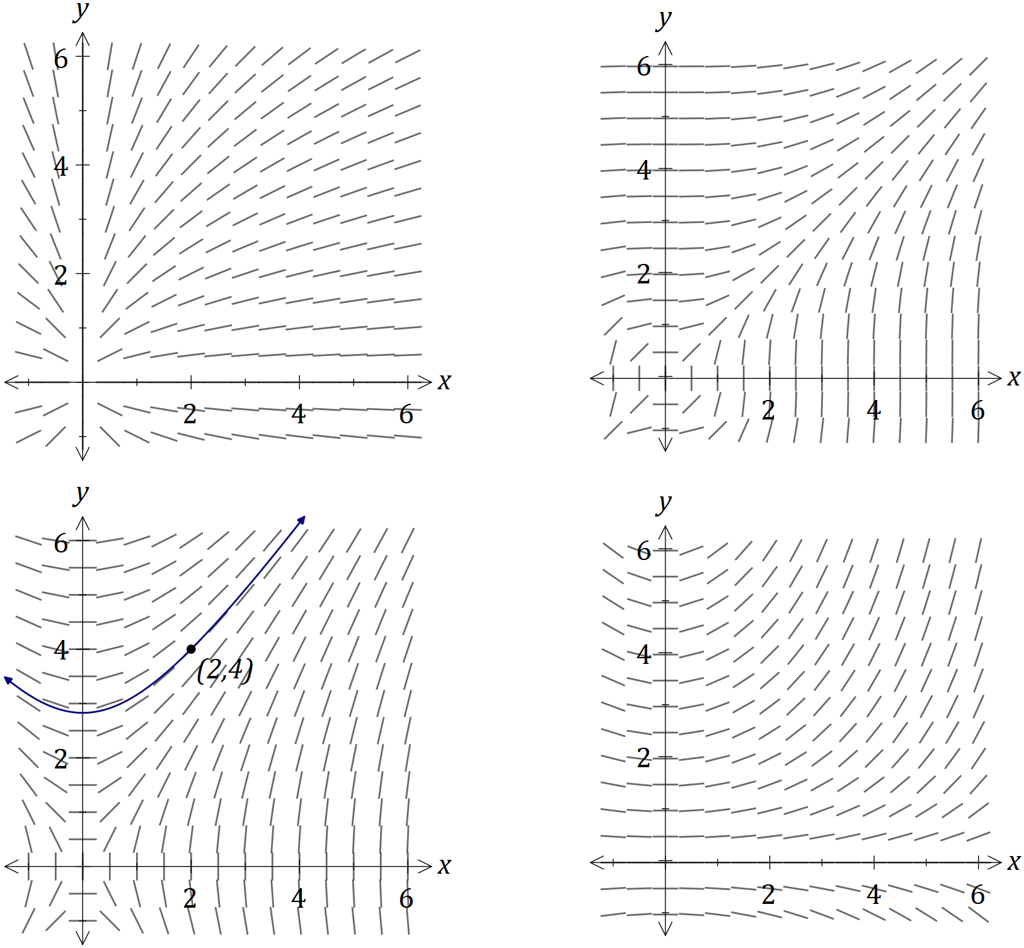

|  |
| --- |
| **Solution** |
| See bottom left-hand slope field |
| **Specific behaviours** |
| ✓ chooses correct slope field  ✓ uses slopes to sketch solution curve right of pt.  ✓ uses slopes to sketch solution curve left of pt. |

On the slope field for , sketch the solution of the differential equation that passes through the point . (3 marks)

**Question 4 (3 marks)**

A cube of side x is slowly increasing.

Use a calculus method to determine the increase in the surface area of the cube as  increases from 10 to 10.1 cm.





✓

✓

The increase in surface area, when the side increases from 10 to 10.1 cm,

✓

is 12 cm2.

Question 5 (4 marks)

A floating pontoon at a tidal marina is connected to the top of the harbour wall by a hinged walkway AB of length 13 metres.



When the top of the pontoon, B, is 5 m below the top of the wall, A, the sea is rising at a rate of 2 cm per minute.

At this instant, calculate the rate at which the barge is moving away from the wall.



|  |
| --- |
| ✓ Equation of y in terms of x  ✓ differentiate  ✓ substitute in values for x and y  ✓ Answer |

**MATHEMATICS SPECIALIST UNIT 3&4 Name Solutions**

**TEST 5, 2017**

You must show all working

**Section One: Resource Rich**

Time: 30 minutes Total marks: 30 ________________________________________________________________________________________

Question 6 (13 marks)

(a) Show that the gradient of the curve at the point is . (3 marks)

|  |
| --- |
| **Solution** |
|  |
| **Specific behaviours** |
| ✓ correctly differentiates LHS  ✓ correctly differentiates RHS  ✓ substitutes x and y values and simplifies to show gradient |

(b) Another curve passing through the point has gradient given by .

Use a method involving separation of variables and integration to determine the equation of the curve. (4 marks)

|  |
| --- |
| **Solution** |
|  |
| **Specific behaviours** |
| ✓ separates variables  ✓ integrates both sides  ✓ eliminates natural logs  ✓ determines constant and writes solution |

(c) A particle is moving along the curve given by , with one unit on both axes equal to one centimetre. When , the y-coordinate of the position of the particle is increasing at the rate of 2 centimetres per second.

(i) Show that the x-coordinate is increasing at 6 centimetres per second at this instant.

(2 marks)

|  |
| --- |
| **Solution** |
|  |
| **Specific behaviours** |
| ✓ uses chain rule  ✓ shows substitution of x-coordinate and given rate |

(ii) Determine the exact rate at which the distance of the particle from the origin is changing at this instant. (4 marks)

|  |
| --- |
| **Solution** |
|  |
| **Specific behaviours** |
| ✓ determines expression for distance in terms of one variable  ✓ differentiates expression wrt to variable  ✓ substitutes, using chain rule  ✓ simplifies in exact form |

**Question 7 (5 marks)**

Some technetium-99m produced at 9 a.m. had an activity of 20 units. By 10 a.m. it had decreased to 18 units. An activity of over 7 units is need for it to be useful for radiation therapy. Given that the activity decreases according to ,

find the time that it ceases to be useful.

 = −k 

ln(a) = −kt + c ✓

a = Ae−kt

Let t = 0 h at 9 a.m., then A = 20 ✓

a = 20e−kt

Now, at 10 a.m., t = 1 and a = 18, so 18 = 20e−k

k = −ln(0.9) ✓

For a = 7, 7 = 20e−kt

t =  = 9.964 ≈ 9 h 58 min ✓

The technetium-99m is no longer useful after 6.58 p.m. ✓

**Question 8 (7 marks)**

The number of deaths from Avian (bird) Influenza in Cambodia was reported to the World Health Organisation (WHO).

Over the years 2010-2015 the number of deaths from Avian Influenza can be

determined by the equation  where  is in years where 

(a) Determine the number of deaths in Cambodia from Avian Influenza in 2012. (1 mark)



✓

(b) (i) Find the rate of increase of cases of Avian Influenza in 2015. (2 marks)





✓

✓

(ii) Is the number of cases increasing or decreasing in 2013? (2 marks)



 ✓

Positive so increasing.

✓

(c) Sketch the shape of the curve (2 marks)

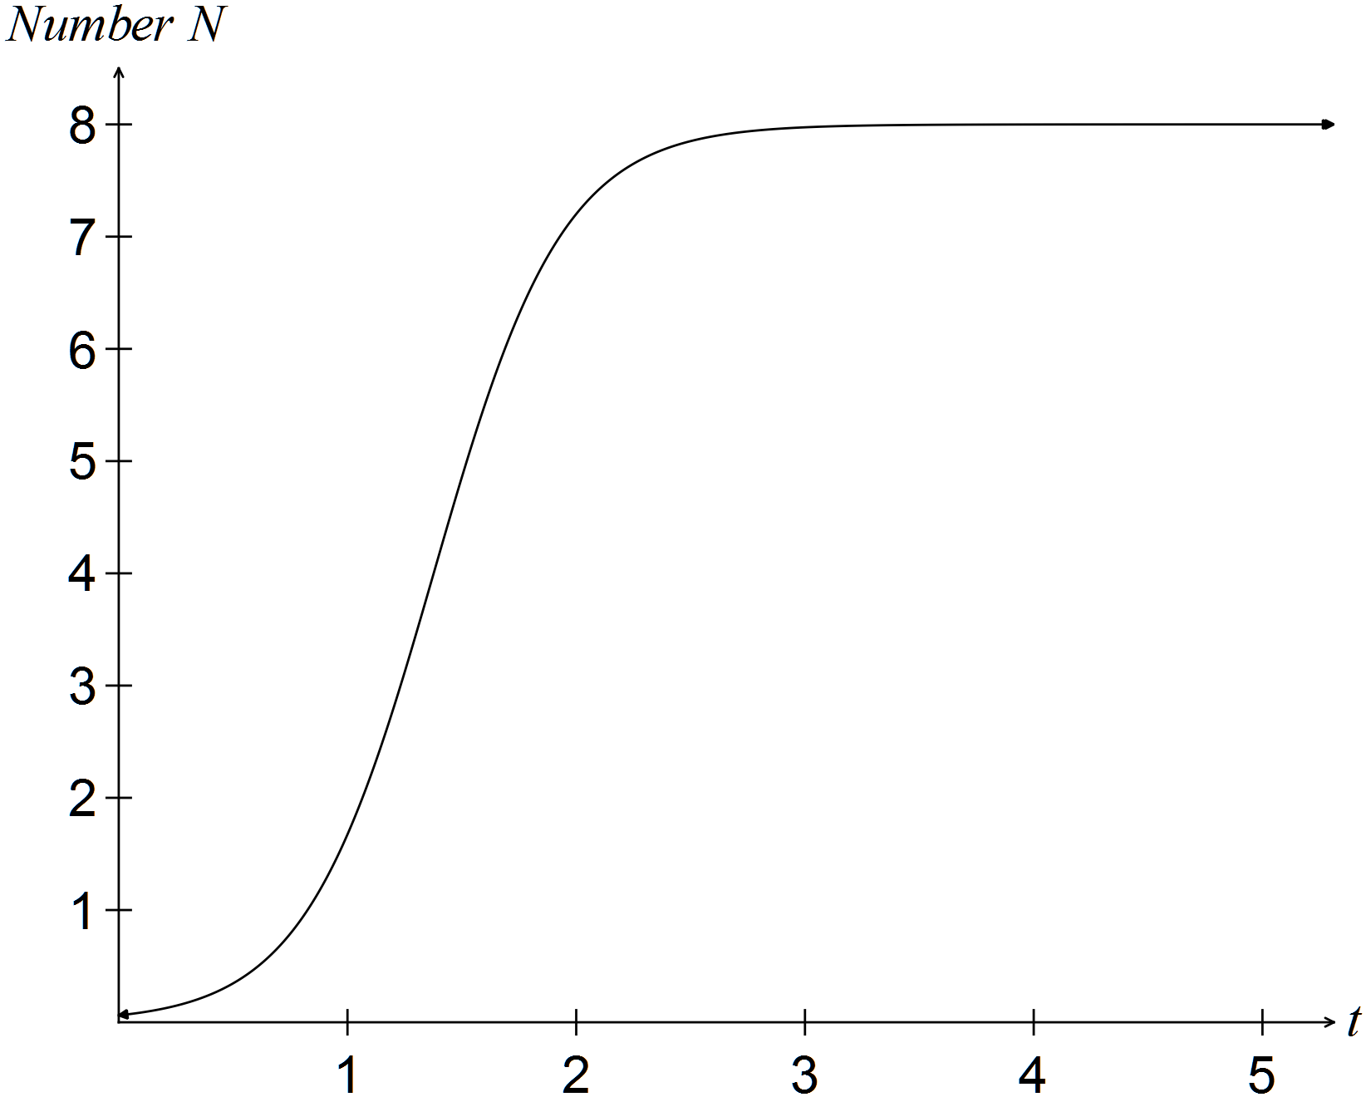

✓

✓

**Question 9 (5 marks)**

Consider the direction graph below.

(a) 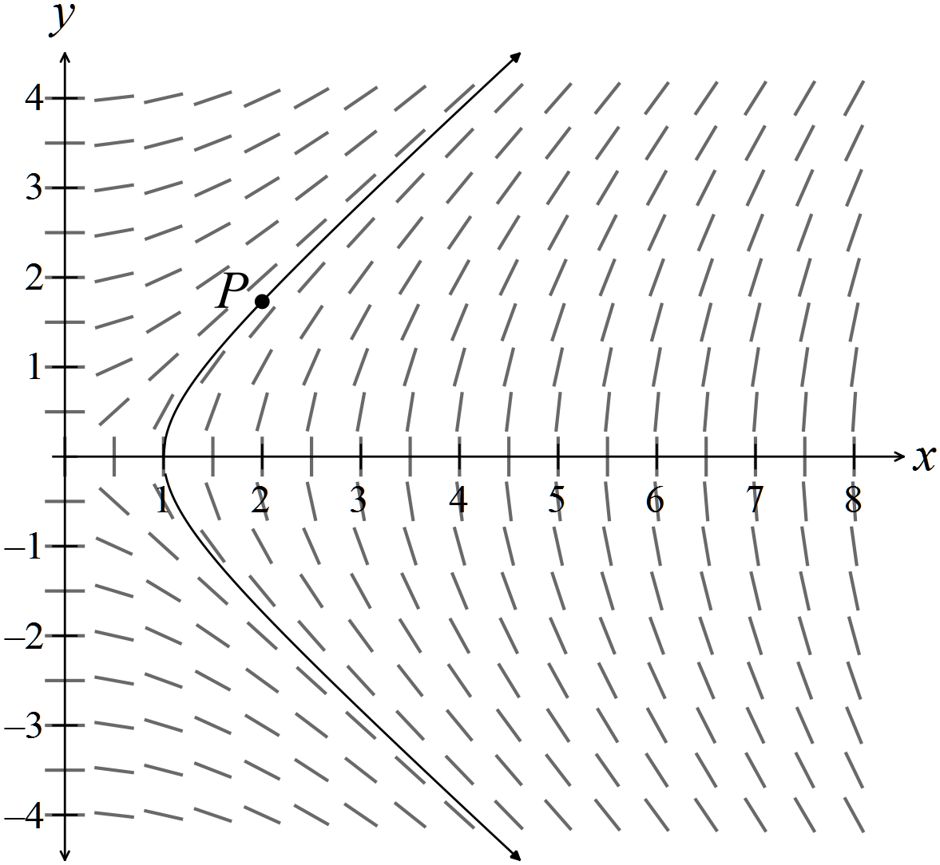✓✓

(b) The shape of the slope field changes as the starting point changes.

At (4,0), the gradient is not defined. At (4,1), the gradient is steep, but becoming

less steep as the y value increases; at (4,3) the gradient is close to 1

As the y value decreases from y = 0, the slope changes from undefined to close

to -1.

✓ states gradient is not defined at (4,0)

✓ describes the shape of the curve above the x- axis

✓ describes the shape below the x-axis